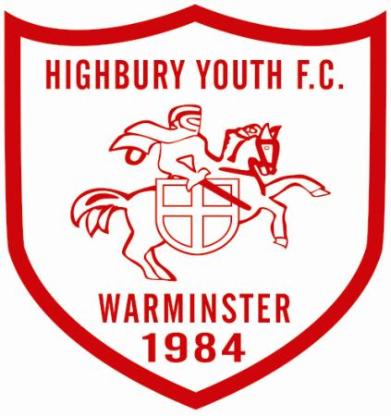
Warminster Highbury Youth FC Football Tournament 25th and 26th May 2019
Founded in 1984, Celebrating 35 Years of Grassroots Football
Affiliated to Wiltshire County FA

All of the boxes need to be filled in before the entry will be accepted (including Club Affiliation Number)
Please ensure if you are entering more than one team you include the team’s names eg: Reds, Blacks, and Stripes.

Club Name (In Full):

Affiliation Number:

Club Secretary Name:

Club Secretary Email:

Managers Name:

Manager Mobile Number:

Managers Email:

Team Name: (Please include if you enter more than one team. EG: Reds, Blacks and Stripes. | Age Group: | Ability ( A,B,C, *A is the highest) | Managers Name (If different from above) | Fee (£25 per Team)
Closing Date: Saturday 4th May 2019 Cheques payable to ‘Warminster Highbury Youth FC’ or email me for BACS Payment details. Please ensure all the boxes are filled out.
Completed Entry Forms can be emailed to allisonfear@googlemail.com. Forms can also be posted with cheques or cash to our Club Secretary Allison Fear. Address: 57, The Teasels, Warminster, Wiltshire, BA12 8NU. Email allisonfear@googlemail.com if you have any questions or need the BACS payment details.

