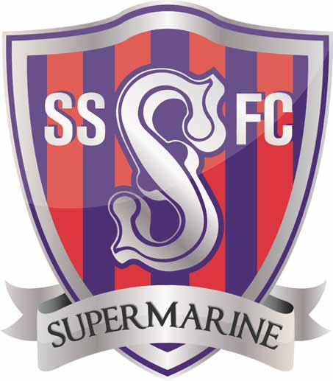
SWINDON SUPERMARINE YOUTH FOOTBALL CLUB.
SIX-A-SIDE TOURNAMENT INVITATION
Dear Youth Football Club
We are writing to you to invite your team to participate in our third six-a-side tournament, which has been very successful and enjoyable over the past couple of years.

The event is on Saturday 2nd and Sunday 3rd June 2018 at the SSYFC home pitches (SN3 4BZ) and the entry price is £20 per team, with a maximum squad size of 8 players. The matches will be officiated by qualified referees and follow the FA Rules and Guidelines.
Under 7’s will play in a non-competitive format and all participants will receive a medal, Under 8’s and above will play in a competitive competition with the format communicated a few weeks before the tournament along with the tournament rules.
Age groups are as the current playing season 2017-18
Saturday 2nd June AM | Sunday 3rd June AM
U8 (competitive) | U7 (non-competitive)
U10 (competitive) | U9 (competitive)
U12 (competitive) | U11 (competitive)
U14 (competitive) | U13 (competitive)  U15 (competitive)
Saturday 2nd June PM
Girls U8 – U16 (competitive)
Girls can play in the mixed or girls only category

Registration for the morning will be before 9.30am and the first matches will kick off at 10am. Afternoon registration will be before 2pm and the first matches will kick off at 2:30pm.
Confirmation of entry will be acknowledged as soon as possible after receipt of the form and payment and entries will not be guaranteed until payment is received.
Closing date for team entries will be Friday 11th May 2018.
We sincerely hope you wish to join us to have a fun day of football. Please fill in the below form and send to Scott Edenborough and Luke Alford via email ssyfc.tournament@gmail.com or post to the address on the form. Payment should be made at the same time by bank transfer, cash or cheque.
We hope to see you there!
Scott Edenborough & Luke Alford
Swindon Supermarine Youth FC

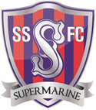 | SWINDON SUPERMARINE YOUTH FC  A Charter Standard Club  SIX-A-Side FOOTBALL TOURNAMENT  2nd & 3rd June 2018  ENTRY FORM

Club Name: |  | Affiliation No:
Manager Details: | Name:  Address: | Telephone:
 |  | Email:
Payment: | Cash Cheque Bank Transfer

Age Group | Boys/  Girls | Team Name |  | Manager (if different to above)  Telephone and Email | Payment Due
 |  |  |  |  | £20
 |  |  |  |  | £20
 |  |  |  |  | £20
 |  |  |  |  | £20
 |  |  | Total:
Please send completed forms to: ssyfc.tournament@gmail.com or posted to Scott Edenborough, 29 Calder Close, Swindon, Wiltshire, SN25 3QF by Friday 11th May 2018.
Payment to be made at the same time either by bank transfer to Account: 61219789 - Sort Code: 60-21-40 (Ref: Your club name & age group), cash or cheque payable to Scott Edenborough. A receipt can be provided on request.
Any Queries by email to ssyfc.tournament@gmail.com or phone Scott – 07917890155, Luke - 07554998388

