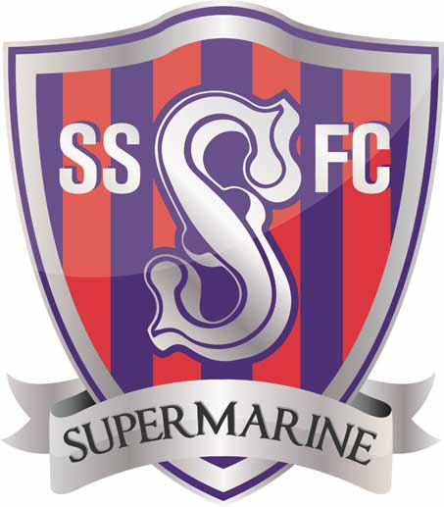
SWINDON SUPERMARINE YOUTH FOOTBALL CLUB.
SIX-A-SIDE TOURNAMENT INVITATION 2019
Dear Youth Football Club
We are writing to invite your team to participate in our annual six-a-side youth tournament, which has been very successful and enjoyable over the past couple of years.

This year’s event will take place on Friday 5th, Saturday 6th and Sunday 7th July 2019 at the SSYFC home pitches (SN3 4BZ) and the entry price is £25 per team, with a maximum squad size of 10 players. The matches will be officiated by qualified referees and follow the FA Rules and Guidelines.
Under 7’s will play in a non-competitive format and all participants will receive a medal, Under 8’s and above will play in a competitive competition with the format communicated a few weeks before the tournament along with the tournament rules.
Age groups are as the current playing season 2018-19
Friday 5th July PM  6PM KICK OFF  U15 (competitive) PM  U14 (competitive) PM | Saturday 6th July  AM KICK OFF  U7 (non-competitive) AM  U9 (competitive) AM  Saturday 6th July  PM KICK OFF  U11 (competitive )PM  U13 (competitive) PM | Sunday 7th July  AM KICK OFF  U8 (competitive) AM  U10 (competitive) AM  U12 (competitive) AM

Registration & Entry Details
- AM registration will be from 9.00am and the first matches will kick off at 10am.
- PM registration will be from1pm and the first matches will kick off at 2pm.
- Confirmation of entry will be acknowledged as soon as possible after receipt of the form and payment
- Entries will not be guaranteed until payment is received.
- Closing date for team entries will be Sunday 2nd June 2019..
- Please complete the attached entry form and send via email to ssyfc.tournament@gmail.com
- or please post to SSYFC, Unit 11,The Orbit Centre, Swindon, Wilts, SN6 6JF

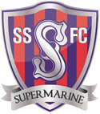 | SWINDON SUPERMARINE YOUTH FC  A Charter Standard Club  SIX-A-Side FOOTBALL TOURNAMENT  5TH ,6TH & 7TH July 2019
Club Name: |  | Affiliation No:
Club Details: | Name:  Address: | Telephone:
 |  | Email:
Payment Type: | Cash Cheque Bank Transfer
Payment Reference
PLEASE COMPLETE 1 ENTRY FORM PER TEAM
Date | Age Group | Team Name | Coach Name | Coach Contact Detail
Fri 5th July PM | U15
Fri 5th July PM | U14
Sat 6th July AM | U7
Sat 6th July AM | U9
Sat 6th July PM | U11
Sat 6th July PM | U13
Sun 7th July AM | U8s
Sun 7th July AM | U10s
Sun 7th July AM | U12S
 |  |  |  | Total £25.00

Payment Info
Club account details Bank: HSBC
Sort Code: 40-43-41
Account Name: Swindon Supermarine Youth FC
Account Number: 71703021
All cheques payable to Swindon Supermarine Youth FC
Please Send cheques & entry forms to
Swindon Supermarine Youth FC, Unit 11,The Orbit Centre, Swindon, Wilts, SN5 7YG

