# Clivey and Twist

**Patron: The Right Reverend Dr. Lee Rayfield – Bishop of Swindon Dioceses of Bristol**

***“Helping Children & Young People to Help Themselves since 2001”***

‘Children and Young People’s Project’ 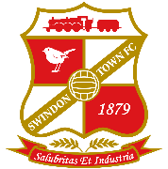Annual Fundraising Charity Event

**An Evening of fun With**

**Swindon tOWN 1969 league cup Winners ‘LEGENDS’**

**and ‘special mystery guest’**

[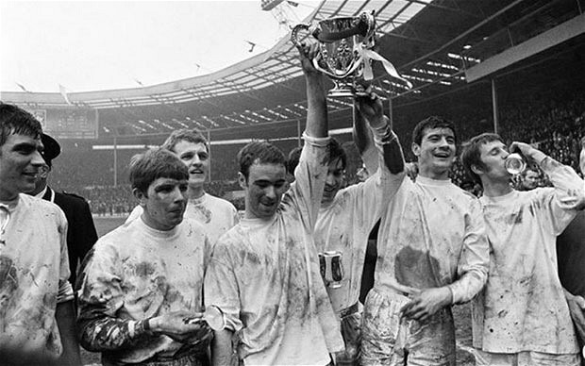](http://www.google.co.uk/url?sa=i&rct=j&q=&esrc=s&source=images&cd=&ved=0ahUKEwi5tODl-vTLAhUKWRoKHTApDroQjRwIBw&url=http://www.telegraph.co.uk/sport/football/competitions/league-cup/9821821/Can-League-Cup-heroes-Bradford-City-follow-in-the-footsteps-of-European-legends-Swindon-Town.html&psig=AFQjCNHv-cQH_9vbi9wc7HTV5qBWB4enCA&ust=1459858481611128) 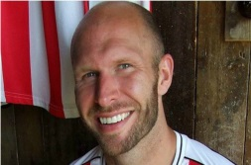

**Marriott Hotel, Swindon. SN3 1SH**

**Master of Ceremonies – Sam Parkin – BBC wILTSHIRE**

**Admission by Ticket Only**

**light 2 course Supper with Tea or coffee**

**Cost**

**Table of 10 - £250.0 or £25 per person**

**Monday 11th July 2016 – 7pm onwards**

**Dress Code Smart Casual – no jeans please**

