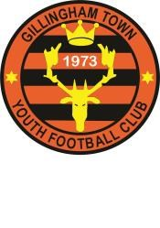
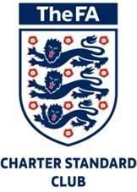Gillingham Town Youth Football Club

Dorset F.A. Club Affiliation Number UDOR 0725

Gillingham Town Youth Football Club
6-aside Football Tournament
Saturday 13th & Sunday 14th July 2019 @ Kington Magna, Gillingham, Dorset, SP8 5ED

Dear all

GTYFC are pleased to announce they are holding a tournament this year. It will be held over two days on Saturday 13th July and Sunday 14th July 2019. This will be for both boys and girls teams. The tournament has been sanctioned by Dorset FA.

The tournament is open to age groups from U8 to U16. U8 to U13 playing Saturday and U14 to U16 playing Sunday.

Please find attached the tournament rules and entry form. Please take a look and see if any teams in your club are interested in entering.

Entry fees are £25 per team, closing date for entries is 30th May 2019 and places will be given on a first come, first served basis.

If you have any questions please do not hesitate to contact me.

We look forward to hearing from you.

Kind regards,

Claire Parker
Gillingham Town Youth FC Secretary

