PRESS RELEASE
SWINDON TO BECOME THE CENTRE OF SOUTH WEST FUTSAL & EDUCATION DEVELOPMENT

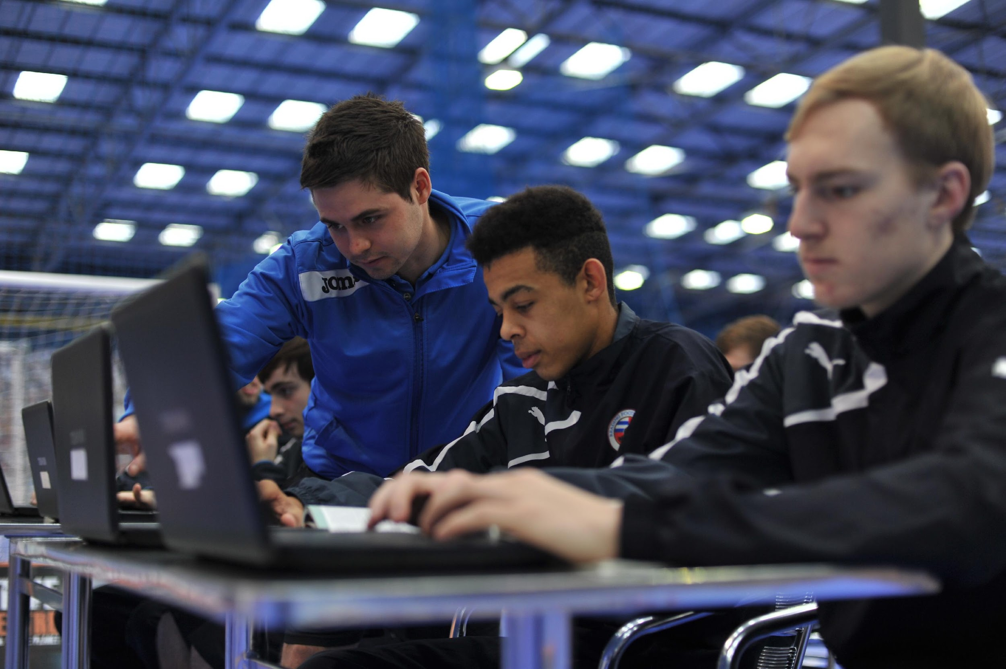

Scholars will study towards a BTEC Level 3 Extended Diploma in Sport whilst competing in the Futsal National Development League (NDL)

Swindon is set to become the centre for Futsal education development throughout the South West. The state-of-the-art indoor @Futsal arena - located in Kembrey Park - will provide the base for one male and one female Futsal Academy, whilst becoming the regional hub for several other Academies.

Dominic Virgilio, Recruitment Manager at the arena, commented: "We're really proud to see our arena establish itself as the focal point for a flourishing Futsal education network. We've had scholars learn and train from the arena over the last couple of years, but with the launch of the new Pro-Club NDL programme, the level of activity is drastically increasing. Our relationship with Reading Football Club is testament to the drive and ambition that we've shown so far, and we're obviously delighted to have their Swindon satellite here at the arena. We're also honoured to establish the Swindon College Female Futsal Academy here at the arena and can't wait to see some Lionesses emerging from the programme!"

The Futsal NDL programme sees professional football clubs around the country partnering with @Futsal Group in order to deliver their Futsal BTEC qualification, whilst competing in an officially sanctioned national games programme. The qualification is the equivalent of 3 A-Levels, and is combined with employability skills and careers advice. These are the next generation of study programmes incorporating the game of Futsal as an enrichment activity, and feature the world's first dedicated Futsal coaching syllabus.

As well as hosting the aforementioned Reading FC satellite hub and the brand new Swindon College Female Futsal Academy, the arena will also be a regional contact point for Futsal Academy programmes at Oxford City FC, the Madejski hub of the Reading FC Academy, Bristol-based organisation Sporting Chance Project and Bicester-based organisation Ignite Sport UK.

Since creating and developing their own Futsal study programmes, @Futsal Group have gone on to launch two flagship nationwide schemes which will take full effect this September. After teaming up with Association of Colleges for Sport (AoC Sport) and the English Colleges Football Association (ECFA) to develop a pilot scheme for the 2014/15 academic year, they also launch their National Colleges & Academies (NCA) programme, which sees educational establishments delivering a similar model to the Futsal NDL.

Both the NDL and NCA programmes are taught using @Futsal Group's bespoke virtual learning platform, which is called 'Inspire'. This allows scholars to work remotely on electronic devices; accessing a range of media content in order to enrich their modules, whilst also receiving instant feedback and assessment from their tutors online. The blended learning environment is tailored towards a contemporary approach to studying, ensuring that both the learners and tutors receive as much support as possible.

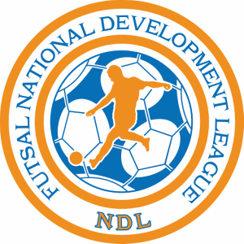@Futsal Group have a solid business background, and established themselves as the UK's market leaders for the provision of Futsal whilst beginning to develop their education programmes. As such, they have a unique base of expertise in all three fields of business, sport and education. Their national spine of state-of-the-art arenas serve as Futsal centres of excellence as well as vibrant multi-sport hubs, and the Reading F.C. Futsal Academy also has a satellite pod at @Futsal Group's Swindon arena.

Frank Rodriguez, Chief Executive of @Futsal Group, commented: "This programme provides a unique experience in education and Futsal for all of the scholars involved. What we have developed is unique and world class.
It is a fantastic opportunity for anybody that shares our own drive, ambition and commitment to quality. The enrichment of working with a professional football club really demonstrates the level of opportunity available for the young people that sign up to this programme.
We're delighted to be working so closely with clubs and organisations of this calibre and look forward to seeing the fruits of our partnership emerging from both the Futsal pitch and the classroom."

The Futsal NDL games programme is officially sanctioned, and features match-days at each of @Futsal Group's arenas. Representing their respective clubs, scholars will battle it out in regional divisions with the hope of qualifying for the national Grand Finals, which will take place in Birmingham - the largest indoor Futsal facility in Europe. Match highlights and interviews will be broadcast on Futsal NDL TV, and players will have access to an online management portal as well as a range of interactive social media platforms.

Georgia Graham, a Futsal Academy graduate and currently the full-time Assistance Disability & Activities Officer at Reading Football Club, commented: "If it wasn't for the education and Futsal scholarship, I wouldn't be where I am today. I have such a passion for football and Futsal, so being able to work at Reading Football Club now is a real privilege and that dream came true because I joined the Futsal Academy programme."

Any scholars looking to apply for one of the programmes can access more information and apply by visiting http://www.futsaluk.net/education. They can also contact mailto:education@futsaluk.net and stay updated by following Futsal NDL on Twitter or heading to Facebook.

